EX NO: 1 | Build a LAN topology in Cisco Packet Tracer
DATE:

Objectives
- To implement a star topology using Packet Tracer and hence to transmit data between the devices connected using a star topology.
- To implement a Mesh topology using Packet Tracer and hence to transmit data between the devices connected using Mesh topology.
- To implement a hybrid topology using Packet Tracer and hence to transmit data between the devices connected using a tree topology.

Software/Apparatus required:
- Cisco Packet Tracer
- End Devices (PCs)
- Switches
- Copper Straight-through Cable / Automatic Cable Selector

Procedure
Step 1: Start Packet Tracer
  - Launch Cisco Packet Tracer. Step 2: Select Devices
  - Choose the required end devices (PCs).
  - Select the required networking devices (Switch, Hub, or Bridge) according to the topology.
Step 3: Build the Network Topology
  - Drag and place the required PCs and networking devices into the workspace.
  - Arrange the devices according to the specified topology (Star, Mesh, Hybrid, etc.). Step 4: Connect the Devices
  - Select the appropriate cable (Copper Straight-through or Automatic).
  - Connect each PC to the corresponding networking device.

  - Wait until the interface status changes from amber to green after the STP initialization process.
Step 5: Configure IP Addressing
  - Open each PC.
  - Navigate to Desktop, IP Configuration (or Config, FastEthernet0).
  - Assign the IP address.
  - Configure the subnet mask (or allow Packet Tracer to generate it automatically). Step 6: Verify Connectivity
  - Open Desktop and then Command Prompt.
  - Use the ping command to test communication between devices.
  - Alternatively, use Add Simple PDU in Realtime or Simulation mode to verify packet transmission.
  - Confirm successful communication through ping replies or successful PDU status.

Networking Diagram:
Objective (i): Implementation of Star topology

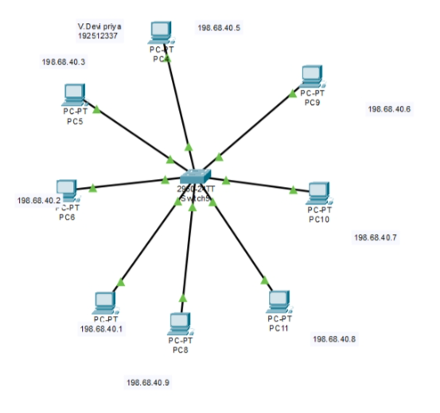

Objective (ii): Implementation of Mesh topology
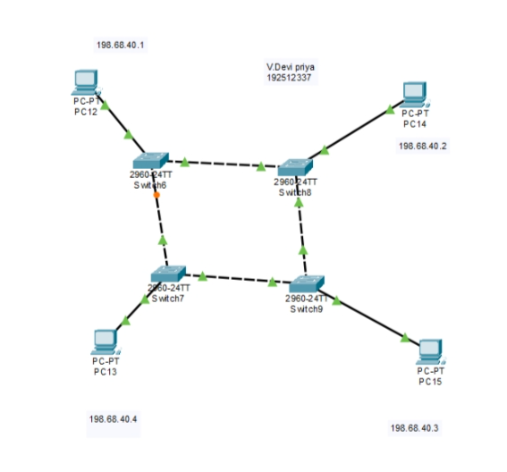

Objective (iii): Implementation of Hybrid Topology

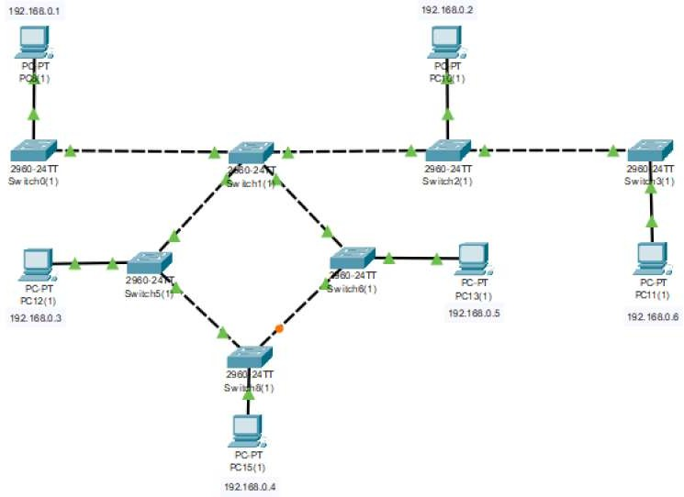

Output
Objective (i): Implementation of Star topology

SI.  No | Source IP | Destination IP | Data sent (bytes) | Data received (bytes)
1 | 192.168.10.1 | 192.168.10.5 | 32 | 32
2 | 192.168.10.2 | 192.168.10.1 | 32 | 32
3 | 192.168.10.3 | 192.168.10.3 | 32 | 32
4 | 192.168.10.4 | 192.168.10.2 | 32 | 32

5 | 192.168.10.5 | 192.168.10.4 | 32 | 32

Objective (ii): Implementation of Mesh topology

SI.  No | Source IP | Destination IP | Data sent (bytes) | Data received (bytes)
1 | 192.168.10.1 | 192.168.10.5 | 32 | 32
2 | 192.168.10.2 | 192.168.10.1 | 32 | 32
3 | 192.168.10.3 | 192.168.10.3 | 32 | 32
4 | 192.168.10.4 | 192.168.10.2 | 32 | 32
5 | 192.168.10.5 | 192.168.10.4 | 32 | 32

Objective (iii): Implementation of Mesh topology

SI.  No | Source IP | Destination IP | Data sent (bytes) | Data received (bytes)
1 | 192.168.10.1 | 192.168.10.3 | 32 | 32
2 | 192.168.10.2 | 192.168.10.4 | 32 | 32
3 | 192.168.10.3 | 192.168.10.2 | 32 | 32
4 | 192.168.10.5 | 192.168.10.1 | 32 | 32
5 | 192.168.10.4 | 192.168.10.5 | 32 | 32

Result
Objective (i): Implementation of Star Topology
The Star topology was successfully created in Cisco Packet Tracer, and communication between the connected devices was verified successfully.

Objective (ii): Implementation of Mesh Topology
The Mesh topology was successfully simulated in Cisco Packet Tracer, and data transfer between all connected devices was confirmed.

Objective (iii): Implementation of Hybrid Topology
The Hybrid (Bus–Ring) topology was successfully established in Cisco Packet Tracer, and successful network connectivity between the connected devices was achieve

